A

There was going to 1.______ an English contest at school. Lin Mei didn’t want to take part in it because she very shy and her English was not good 2._______. But her father 3._______ her to enter the contest. He said, “It’s not important if you’re a winner or not. You can only take it as a 4.________ to improve your English.” Then her father bought her some English tapes and some English 5.________. Also, her father took her to the cinema to see English 6.________. In the morning, after she got up, she listened to English on the radio. Her father offered her such a wonderful learning environment. Gradually, Lin Mei didn’t fear（害怕） to 7.________ English in public. Everyone said she had made great 8.________ in English.

In the contest, Lin Mei 9.________ an English song. To everyone’s surprise, she won the contest! When she10. ___ ____ the award, she said she should thank her father.

B

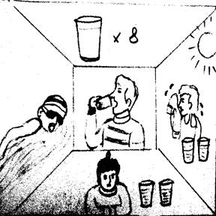

1.__________ all the things we eat and drink, water is the most important. Not many people realize this, but it is quite true. The human body can live 2___________ food for a long time, but two or three days without water usually leads to（导致）death. Many people do not understand how 3.__________ water the human body needs at work and many people do not drink 4._________ especially in cold weather. Most people drink enough only in 5.___________ weather. Most people drink when they are 6.___________, but we often need more water, especially 7.__________ doing exercise.  
 A man’s body contains 65%-75% water. Water is very important in several different 8.__________. Most people need about five to seven liters（升）of water every day, but we do not need to drink that amount（量）, 9.____________ a lot of water comes from the food we eat. If we do not have enough water, however, we 10.____________ tired and may become ill.

**参考答案：**

A) 1.be 2.enough 3.encouraged 4.chance 5.books 6.movies 7.speak 8.progress 9.sang 10.won

B) 1.Of 2.without 3.much 4.enough 5.hot 6.thirsty 7.after 8.ways 9.because 10.feel