Module 12 Western music
Unit 3 Language in use
设计说明  本单元以两位名人导入，激发学生的学习兴趣。然后通过连词成句训练选择疑问句；通过将陈述句改为感叹句，引导学生深入记忆感叹句的结构与用法；通过用所给词的适当形式填空，巩固所学单词的重要用法；最后通过谈论中国音乐，全面提升学生灵活运用本模块所学语言知识的综合能力。  教学目标  通过本单元的教学，让学生达成以下目标:  1.知识目标：  掌握重点句子: 1. Me too. 2. That’s sad! 3. Every year, the Vienna New Year’s Concert takes place on 1st January. 4. It is a classical music concert and it always includes pieces of music by the Strauss family.  2.能力目标：  （1）通过做题，提升运用所学知识的能力。  （2）能用上本模块所学的感叹句和选择疑问句，谈论中国音乐。  3.情感目标：  了解中国的音乐，陶冶情操，提高修养；提高学习英语的兴趣，树立信心，将所学知识应用到生活实际之中去。  重点难点  重点：本模块所学的重点单词、短语、句型，以及感叹句和选择疑问句。  难点：感叹句和选择疑问句的用法。  教学准备  PPT课件; 课本。  授课时数  1课时  教学过程  Step 1 Language practice  翻译下列句子。  What a beautiful city!  多美丽的城市啊！  Do you like traditional Western music or pop music?  你喜欢传统西方音乐还是流行音乐？  Step 2 Grammar 1  1. Lead students to describe the pictures with exclamations.  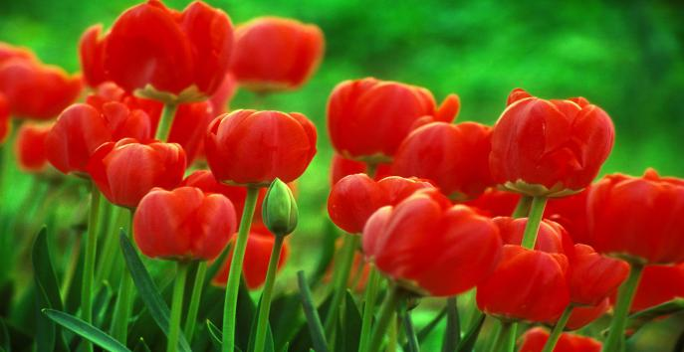  The flowers are beautiful.这些花很漂亮。  What beautiful flowers they are! 多么漂亮的花啊！  The cat is lovely.这只猫很可爱。  What a lovely cat it is!多么可爱的猫啊！  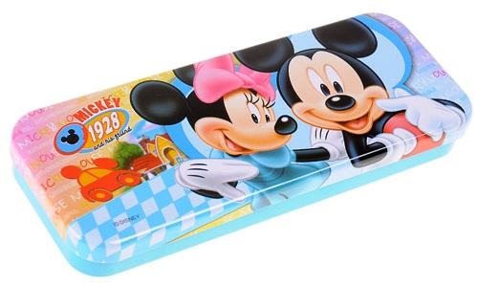  The pencil box is big.这个铅笔盒很大。  What a big pencil box it is!多么大的铅笔盒啊！  The girl is pretty.这个女孩很漂亮。  What a pretty girl she is!多么漂亮的女孩啊！  2. Teach students exclamations.  感叹句  感叹句是一种表示强烈情感的句式，能表达喜悦、愤怒、悲哀、惊奇、厌恶和赞赏等感情。  What a beautiful flower it is! (表示赞赏)  多漂亮的花啊！  How strange they are! (表示惊奇)  多奇妙呀！  what引导的感叹句：  What（a / an）+形容词+名词（+主语+谓语）!  What a lovely girl she is!多么可爱的女孩啊！  What an easy question it is!多么简单的问题啊！  What interesting films they are!多么有趣的电影啊！  What important news it is!多么重要的消息啊！  3. Write exclamatory sentences with What (a)…!.  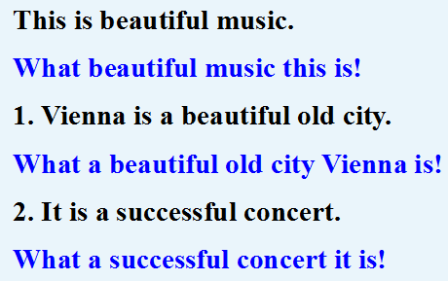  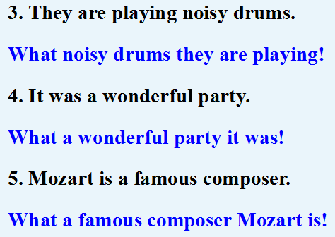  4.感叹词（以及副词、形容词）表示的感叹句：  Oh! 啊！哦！哎哟！  Well! 好啦！  Why! 什么（话）！嗯！岂有此理！好好！  Excellent! 好极了！  短语表示的感叹句：  Dear me! 哎呀！  Great Heavens! 天哪！  带有强烈感情的语调说出的陈述句、疑问句和祈使句变成的感叹句（书面语，句末用感叹号）：  I am so angry! 我太生气了！  Could one have believed it! 谁肯相信这个！  Don’t you say that again! 你可不要再说那个了！  Happy birthday, Tony! 生日快乐，托尼！  Step 3 Grammar 2  1. Observe the following sentences carefully. Pay attention to the words in red.  1 Do you like traditional Western music or pop music?  2 Is this by Strauss or Mozart?  3 Is it by the father or the son?  4 Shall we go home or stay here?  5 Did you come here by bus or by car?  2. Teach students Alternative questions.  选择疑问句  在问句中提供两个或两个以上可选答案的问句叫选择疑问句。选择疑问句的两种或两种以上的情况用or连接，回答时不能用yes或no。在口语中，选择疑问句的语调应是第一个选择项读升调，第二个选择项读降调。选择疑问句可以分为一般选择疑问句和特殊选择疑问句两种。  一般选择疑问句  句型：一般疑问句+or +被选择的情况？  — Are you a teacher or a student?  你是老师还是学生？  — I’m a student. 我是学生。  — Did you work out the maths problem in this way or (in) that way?  你是用这种方法还是用那种方法把这道数学题算出来的？  — I did it in that way.  我是用那种方法算出来的。  特殊选择疑问句  句型：特殊疑问句, A or B?  — Which is bigger, Beijing or New York?  哪个城市大些，北京还是纽约？  — Beijing. 北京。  — When will he leave for London, today or tomorrow?  他何时动身去伦敦，今天还是明天？  — Tomorrow. 明天。  注意 ：  1. or之后如果是单数可数名词，必须要加上冠词。  2. 选择疑问句中or所连接的可以是不同的内容，如两个名词，两个动词，两个介词短语等。但or所连接的内容一定是并列的，如果or的前面是名词，其后也应该是名词；如果是动词，其后也必须是动词。不能前面是名词，后面却接一个动词。  3. Practice  Write questions.  You / like / pop / traditional music?  Do you like pop or traditional music?  1. (be)/Strauss/ German/Austrian?  Is Strauss German or Austrian?  2. (be)/ this/ pop/ rock?  Is this pop music or rock music?  3. They/ play /traditional music/ modern music?  Do they play traditional music or modern music?  4. He/ play/ piano /violin?  Does he play the piano or the violin?  5. Where/(can)we/hear/ rock music /in/ New York/ London?  Where can we hear rock music, in New York or in London?  Step 4 Do the other exercises on the textbook.  1. Put the words and expression into the correct column.  drum fan musician piano pop rock traditional music violin  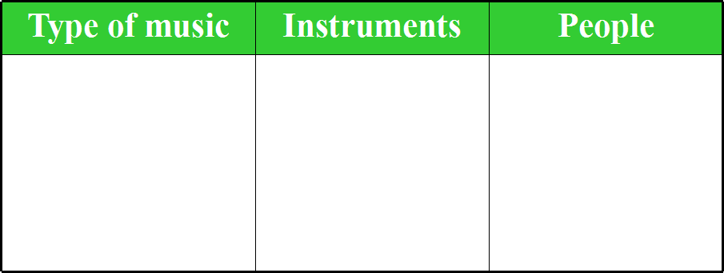  Answers：  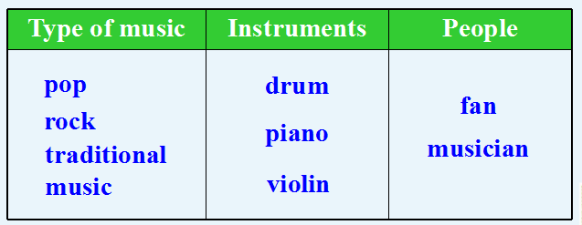  2. Complete the conversation with the correct form of the words from the box.  come give hear learn love write  Lingling: This is beautiful music. Who wrote it, Betty?  Betty: Beethoven wrote it. He was a great musician. I (1)______his music.  Lingling: Me too. Did he live at the same time as Mozart?  Betty: Yes, he was born in 1770 and began to (2) ___________music at an early  age. He (3) ___________his first piano concert when he was only seven.  Lingling: When did he start to (4)_____music?  Betty: Very early. His first work (5) _____out before the age of thirteen.  Lingling: Was Beethoven famous at that time?  Betty: Yes. But he began to lose his hearing. In the last ten years of Beethoven’s  life, he (6)______nothing.  Lingling: That’s sad!  Betty: Yes, but he still played the piano. He died when he was fifty-six.  Answers：（1）love （2）learn （3）gave （4）write （5）came  （6）heard  Around the world  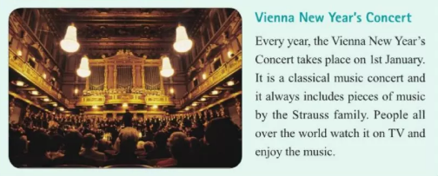  Module task: Talking about Chinese music  3. Work in pairs. Talk about one or two types of Chinese music.  beautiful fast lively modern sad slow  Choose one or two types of Chinese music and describe them. Use the words from the box.  Say which types of music you like. Give your reasons.  Now talk about Chinese music in front of the class.  Step 5 Homework  1. Review the grammar we’ve learned today.  2. Finish the exercises in this module.  当堂达标  I. 根据要求改写句子。  1. Betty enjoys fast music. (用slow music改为选择疑问句)  ______ Betty ______ fast music ____ slow music?  2. His sister is a beautiful girl. (改为感叹句)  _____ _____ ________ girl his sister is!  3. The meat is very delicious. (改为感叹句)  ________ ________ meat it is!  Ⅱ. 根据汉语提示写出正确的英语句子。  1. 你喜欢红色还是蓝色？  _____________________________________  2. 多么大的一个箱子！  _____________________________________  3. 你们是骑自行车还是坐公交车去公园的？  _____________________________________  4. 多么美味的食物啊！  _____________________________________  5. 这些照片多漂亮啊！  _____________________________________  Ⅲ. 完成感叹句。  1. ________ difficult homework we had yesterday!  2. ________ cute dog it is!  3. ________ honest boy Tom is!  4. ________ tasty smell the cake gave off!  5. ________ good time we had on the beach yesterday!  6. ________ exciting news you’ve brought us!  答案：I.1.Does, enjoy, or 2.What a beautiful 3.What delicious  II.1. Do you like red or blue?  2. What a big box (it is)!  3. Did you go to the park by bike or by bus?  4. What delicious food (it is)!  5. How beautiful the photos are!  Ⅲ.1.What 2. What a 3. What an 4. What 5. What a 6. What  板书设计  III.1.What 2.What a 3.What an 4.What 5.What a 6.What  Unit 3 Language in use  what引导的感叹句  What（a / an）+形容词+名词（+主语+谓语）!  What a lovely girl she is!多么可爱的女孩啊！  What interesting films they are!多么有趣的电影啊！  What important news it is!多么重要的消息啊！  一般选择疑问句  句式：一般疑问句+or +被选择的情况？  — Are you a teacher or a student?  — I’m a student.  特殊选择疑问句  句式：特殊疑问句, A or B?  — Which is bigger, Beijing or Shanghai?  — Shanghai.  板书设计 | 教学反思

