Period 1 （Section A la—1c）
设计说明
本课时的中心话题是谈论天气。学会运用“How's the weather?” 及描述天气情况的形容词来谈论不同城市的天气状况;lb采用“打电话”的真实情景，人们就各自城市的天气进行问答，同时也为lc的操练提供了素材。
教学目标
1.知识目标：
掌握单词：rain, windy, cloudy, sunny, snow, weather。
掌握句型：
—How's the weather in Beijing?
—It's sunny.
2.能力目标：
能用所学的知识描述天气情况。
能描述正在发生的事情。
3.情感目标：
引导学生善于观察天气，善于调整自己的情绪;了解世界各地的天气情况;知道大自然的力量是神奇而伟大的。 鼓励学生好好学习，为长大后探索神奇的大自然打好基础。
重点难点
1.重点：
本课时词汇及天气的表达法。
2 .难点：
学会使用how引导的特殊疑问句。
教学准备
课件、录音机、磁带。
教学过程
Step 1 Warming up & Leading in
1.Greet the students and check the homework.
2.Watch a video program about the weather.
e. g.
T：What's the date today?
Ss：It's...
T: Right. So it's late spring/early summer/late autumn/ early winter now. The weather is good/bad today. Look at the sun/cloud/rain/wind/ snow! How is the weather today?
Ss：It's sunny/cloudy/rainy/windy/snowy.(板书新单词)
3.Read the new words and remember them.
4.Translate the new words into Chinese.
(1)rain 下雨;雨水
(2) windy 多风的
(3)cloudy 多云的
(4)sunny 晴朗的
(5) snow 下雪;雪
(6) weather天气
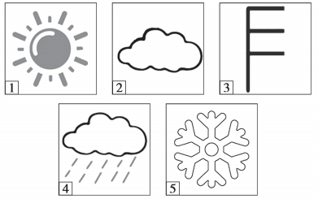
(Show the pictures on the big screen. ) Ask the students to use “How's the weather?”“It's...”to practice the structures.
e. g.
S1：How's the weather in picture 1?
S2：It’s sunny. How's the weather in picture 2?
S1：It's cloudy.
5.Write the words about weather according to the pictures above.
Answers： (1) sunny (2) cloudy (3) windy (4) raining/ rainy (5) snowing/ snowy
Step 2 Practice
1.Look at the pictures in la. Then read the words on the left. Ask the students to match the words with the pictures.
2.Check the answers.
Answers： 1. a 2. b 3. e 4. c 5. d
Step 3 Presentation
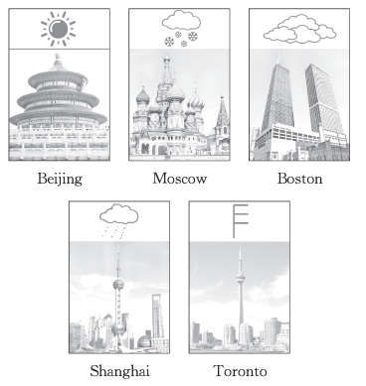
Show some pictures to the students, and ask them to ask and answer in pairs about the weather.
e. g.
T：How's the weather in Beijing?
Ss：It’s sunny.
T：How's the weather in Moscow?
Ss：It’s snowing.
Step 4 Game
(Show some pictures on the big screen.) Ask the students “How's the weather?”.
The students guess and answer the question.
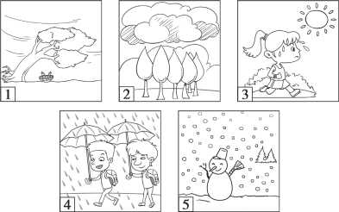
T： How's the weather in picture 1?
S1：Is it rainy?
T： No,it isn't. It's windy.
Step 5 Listening
T：Now let's look at the city names in the box in lb.
Please read after me.
(The students read the city names after the teacher.)
T：Now, we'll hear four conversations. Listen carefully,and point out each city in the picture when you hear it on the tape.
Play the recording a second time. Ask the students to write the name of the city in the picture.
Check the answers.
Answers:a. Toronto b. Boston c. Beijing d. Moscow e. Shanghai
Step 6 Pair work
1.Tell the students: If you are in one of the places in the pictures above, talk about the weather with your friend in another city on the phone.
2.Make a model with a student like this：
T：Hi! How's the weather in Beijing?
S1：It's sunny.
3.The students work in groups.
(1)由对应的名词构成的描述天气的形容词：
sun→sunny
cloud→cloudy
wind→windy
rain→brainy
snow→snowy
(2)谈论某一个地方的天气的句型有：
A.询问某地天气状况的句型为：
How is the weather+in+地点名词？
How is可以缩写为How's。
莫斯科的天气怎么样？
How's the weather in Moscow？
B.It’s+描述天气的形容词+ in+地点名词.
It's sunny in Beijing.北京天气晴朗。
C.地点名词+ be+描述天气的形容词.
Beijing is sunny.北京天气晴朗。
Step 7 Task(The best weather forecaster)
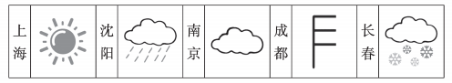
Work in groups to give the weather report.
Report like this：
Here's the weather report for some big cities in China.
It's sunny in Shanghai. It’s. . . in Shenyang...
Here's the weather report for today. Thank you for listening.
Step 8 Summary
In this lesson,we have learned:
Words: rain, windy, cloudy, sunny, snow, weather
Sentence structures:—How's the weather in Beijing? —It's sunny.
Grammar：运用how句型来谈论天气。
当堂达标
（一）根据汉语提示完成句子
1.It's a (多云的)day today.
2.It's (正在下雨)today₉ so I can't go out.
3.It's (有风的)today. I want to take a bus to school.
4.—How's the (天气)in your city?
—It (晴朗的).
5.It is (下雪)now. It's very cold outside.
（二）用所给单词的适当形式填空
1.—How's the weather today in Shanghai?
—It’s (cloud).
2.It's (wind) in spring,just right for flying kites.
3.Put on your raincoat. It's (rain) hard.
4.It hardly ever (几乎从不) (snow) in our city in winter.
5.The weather is (sun) and warm. Let's go out for a walk.
（三）完成下列城市的天气预报
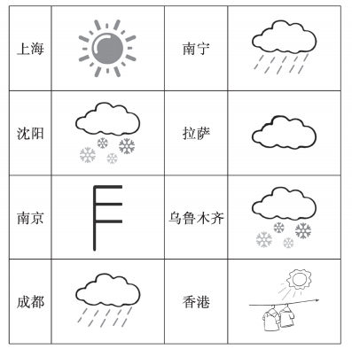
Here's the weather report for some big cities in China. Shanghai

Here's the weather report for today. Thank you for listening.
（四）补全对话(有两项多余)
A.My name is Jack.
B.This is Jack.
C.Tm going fishing.
D.What are you going to do then?
E.Let's meet at our school gate at 4 o’clock.
F.Can I go with you?
G.Tm going for a picnic.
A: Hello! This is Jim speaking.
B: Hi,Jim. 1.
A: Hi,Jack. What's up?
B: Hmm. . . are you free this afternoon? 2. Would you like to come?
A: A picnic? Are you kidding? It's reported that the temperature will stay over 38°C.
B: Oh,that's too bad. 3.
A: I'm going swimming. It's comfortable to swim in this heat.
B: That's a good idea. 4.
A: Sure. When and where shall we meet?
B: 5.
A: OK. See you then.
B: See you.
（五）阅读理解

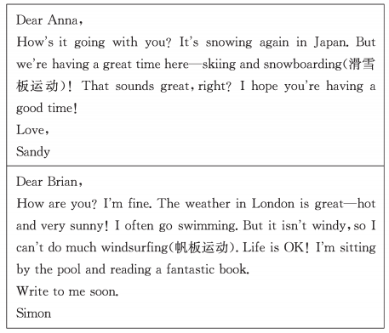
根据短文内容判断正(T)误(F)。
1.Sandy is in Japan. It's raining there. ( )
2.Sandy is having a good time. ( )
3.It's hot and sunny in London. And it's windy?too.( )
4.Simon is doing some reading by the pool.( )
Simon often goes swimming.( )
答案及解析：
（一）1. cloudy cloudy为形容词，意为“多云的”。
2.raining 此处表示“正在下雨”，故应填raining，与空格前的be动词构成现在进行时结构。
3.windy windy为形容词，意为“有风的”。
4.weather； sunny weather为不可数名词，意为“天气”;sunny为形容词，意为“晴朗的”。
5.snowing 此处表示“正在下雪”,故应填snowing，与空格前的be动词构成现在进行时结构。
（二）1. cloudy “It is+adj. ”来描述天气状况。
2.windy
3.raining 根据上文“穿上雨衣”可知，正在下雨,应用现在进行时，故用动词rain的现在分词形式raining。
4.snows 本句在陈述事实，应用一般现在时,it为第三人称单数，作主语时,谓语动词应用第三人称单数形式。
5.sunny
（三）One possible version：
Here's the weather report for some big cities in China. Shanghai is sunny today. It's snowy in Shenyang. Nanjing is windy and Chengdu is rainy. It's rainy in Nanning and it's cloudy in Lhasa. The weather is snowy in Urumqi and sunny in Hong Kong.
Here's the weather report for today. Thank you for listening.
（四）1〜5 BGDFE
（五）1. F 由第一封信中“It's snowing again in Japan. ”可知此题题干表述错误。
2.T 由第一封信中 “But we're having a great time here... ”可知此题题干表述正确。
3.F 由第二封信中“But it isn't windy...”可知此题题干表述错误。
4.T 由第二封信中“I'm sitting by the pool and reading a fantastic book. ”可知此题题干表述正确。
5.T 由第二封信中“I often go swimming. ”可知此题题干表述正确。
Step 9 Homework
1.According to the chart,write a weather report.
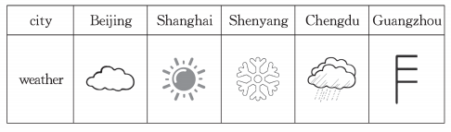
Example:
Hello, everyone! I'm going to give a weather report. It is cloudy in Beijing. It is. . . in Shanghai. . . It is. . . Guangzhou. Thank you.
2.Remember the useful expressions in this class and preview the new words on P38—39.
板书设计
UNIT 7 It’s raining!
Period 1 (Section A la—1c)
rain—rainy/raining  wind—windy  cloud—cloudy  sun—sunny  snow—snowy/snowing  weather | —How's the weather in Beijing?  —It's sunny.
教学反思

