Module 6 Hobbies
Unit 2 Hobbies can make you grow as a person.
设计说明  通过让学生看图片，并选择各种爱好的修饰词，温故知新，导入对这节课的学习。然后，通过略读、精读吃透课文内容，接着学习课文中包含的知识点，再以练习题的形式对课文加以巩固，效果更好。从造句，到成篇，由小到大，步步为营，循序渐进地训练学生的写作技能。  教学目标  通过本单元的学习，让学生达成以下目标  1.知识目标：  掌握生词和短语：person, interest, skill, activity, sailing, result, pleasure, success, look after, as well as, such as, come out, as a result, be interested in  熟记重点句子：As well as the usual activities, such as sailing and climbing, there was a writing class.  Many young people love his book, and as a result, David has become a successful young writer.  I spend some of my free time playing volleyball for my school team.  Some hobbies, for example, reading and painting, are very relaxing.  2.能力目标：  能读懂关于爱好的文章并提取信息，能理解事件发生的顺序  3.情感目标：  培养适合自己的爱好，而且自己的爱好也有利于别人，不损害他人利益  重点难点  重点：理解关于爱好的文章  难点：提取文章信息，理解事件发生的顺序  教学准备  PPT课件，导入爱好的教学图片，教材内容的相关录音  授课时数  2课时  教学过程  Step 1 Warming up  Look at the following pictures, and choose a word to describe the hobbies.  active dangerous healthy creative wonderful interesting lazy funny relaxing useful enjoyable boring  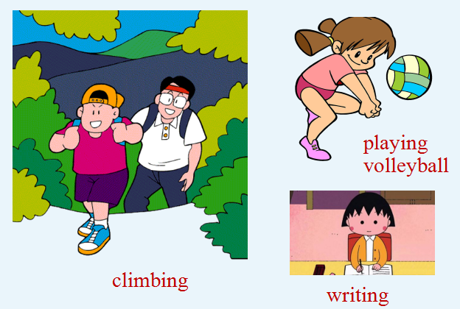  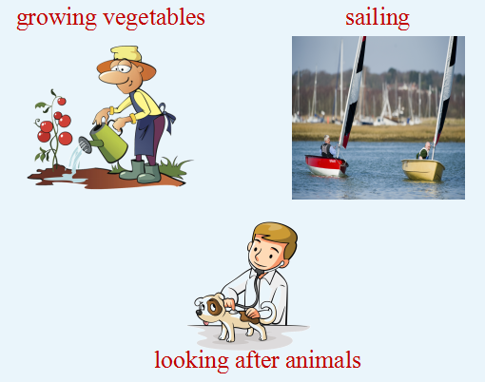  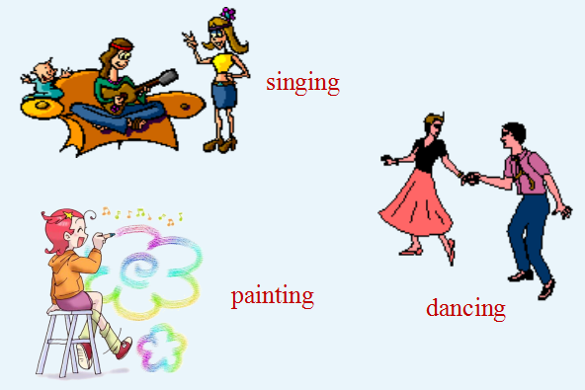  Step 2 Reading  - Fast reading  Ask students to match the meaning with each paragraph.  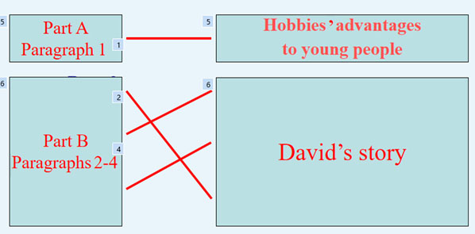  - Careful reading  - Ask students to read Paragraph 1 themselves quietly and find the answer to the following question.  What can hobbies bring young people?  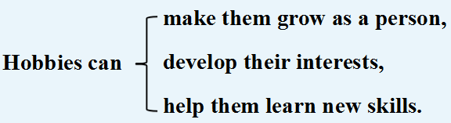  （2）Read Paragraph 2 in groups, discuss and then tell true or false.  a. David spent four weeks at a camp in 2010.  b. He learned playing volleyball during a summer camp.  c. The teacher asked David to talk about his experiences.  Answers：a.T b.F c.F  （3）Read Paragraph 3, fill in the blanks and check in groups.  David wrote a story about _________________ boy, and it _________ as a book. Many young people love it, and ___________, he has become a _______________.  Answers：a sixteen-year-old；came out；as a result；successful writer  （4）Read Paragraph 4, find the answers to the following questions and discuss Question 2 in groups.  a. What has David’s hobby brought him?  b. Will David’s new books be successful?  Answers: a. Pleasure and success. b. Maybe.  - Read the passage again and answer the questions.  a. What advantages can hobbies bring to young people?  b. What hobbies does David have?  c. When did David become a successful writer?  d. Will David’s new books be successful?  Answers:  - Hobbies can make them grow as a person, develop their interests and help them learn new skills.  - David likes writing, playing volleyball and many other things.  - After his story about the life of a sixteen-year-old boy came out as a book in 2012.  - Maybe. The passage doesn’t say that.  Step 3 Language points  - Hobbies can make you grow as a person, develop your interests and help you learn new skills.爱好可以促使你成长，培养你的兴趣，并帮助你学习新技能。  (1)make在此作使役动词，意为“使……”，后面可以接省略to的动词不定式、形容词或名词作宾补。其常用结构如下：  make sb. do sth.  make sb.+adj.  make sb.+n.  His jokes made us all laugh.他的笑话把我们都逗笑了。  Listening to music can make me happy.听音乐可以使我快乐。  We make him our monitor.我们选他当班长。  - develop your interests培养你的兴趣。develop 表示“发展，形成，成长，提高”。  This course can help you develop your speaking skills.  这个课程能帮助你提高口语技能。  Tom has developed into a strong leader.汤姆已成长为一位强大的领导者。  2.During the summer of 2010, he spent four weeks at a summer camp.在2010年暑假期间，他在一个夏令营待了四周。  spend 度过，花费  I spend some of my free time playing volleyball for my school team.  我花费一些空余时间在校队练习打排球。  spend money / time on sth. 在某方面花金钱/时间  spend money /time doing sth. 花金钱/时间做某事  I spent 10 years on/writing the book.我花了10 年时间写这本书。  辨析： spend，take，pay，cost  四者都表示“花费”, 区别是：  sb.spends + some time / money + on /doing sth.  It takes / took sb.+ some time + to do sth.  sb.pays + some money + for sth.  sth.costs (sb.)+ some money  The piano cost May nearly $3,000.这架钢琴花费了梅差不多3000美元。  My parents paid half of their income for my hobby.我父母为我的爱好支付了他们一半的工资。  Joe spent almost a week making the model plane.乔花费了差不多一周的时间制作飞机模型。  It took me half an hour to work out the problem.我花了半小时解出这道难题。  3.As well as the usual activities… 除了常规的活动，还有……  as well as 表示“也, 还, 除……以外还有; 而且”,是并列连词, 用来连接并列成分,后面接名词、代词或动词-ing形式。连接并列主语时, 谓语动词与前一主语保持一致。  The girl is lively as well as healthy.这个女孩健康又活泼。  He as well as his friends likes playing football.  他和他的朋友们都喜欢踢足球。  4. Back at school, David wrote a story about the life of a sixteen-year-old boy, and it came out as a book in 2012.回到学校后，戴维以一名16岁男孩的生活为题材写了一个故事，并于2012年成书出版。  come out 表示“出版, 发行”，还表示“显露”。  The book came out at his early age.  这本书在他年龄还小的时候就出版了。  At last the truth came out. 真相终于大白了。  5…as a result, David has become a successful young writer.  ……结果，戴维成了一位成功的年轻作家。  as a result意为“结果，后果”，与后面的句子用逗号隔开。  注意：so表示“因此”，后面不用逗号隔开。  这个女孩学习一直很努力，因此，她在期末考试的时候考了好成绩。  The girl kept studying hard, and as a result, she got good marks in the final exam.  =The girl kept studying hard, so she got good marks in the final exam.  6. Maybe I’ll write about my volleyball team in my future books.  或许，在我将来的书中我会写一写我的排球队。  maybe与 may be的区别:  maybe作副词，意为“也许;可能;大概”; 作状语时常置于句首。而may be中, may是情态动词, be是动词原形, 两者构成完整的谓语形式。有时二者表述的意思相同。  Maybe she’ll come this afternoon. 她可能今天下午来。  He may be in the office. = Maybe he is in the office.  他或许在办公室。  Step 4 Exercise  1 Complete the sentences with the correct form of the words in the box.  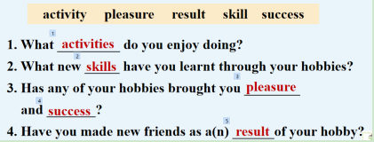  2 Work in pairs. Ask and answer the questions in Activity 4.  1. What activities do you enjoy doing?  2. What new skills have you learnt through your hobbies?  3. Has any of your hobbies brought you pleasure and success?  4. Have you made new friends as a result of your hobby?  Step 5 Writing  1 Look at the following sentences.  As well as the usual activities...  ... such as sailing and climbing...  ... as a result, David has become a successful young writer.  2 Write the following sentences using as well as, such as or as a result.  - Some hobbies, for example, reading and painting, are very relaxing.  - David likes writing. He also likes playing volleyball.  - Many young people love David’s book, and so his hobby has brought him success.  Answers:  - Some hobbies, such as reading and painting, are very relaxing.  - David likes writing as well as playing volleyball.  - Many young people love David’s book, and as a result, his hobby has brought him success.  3 Work in pairs. Find out about the partner’s hobby and make notes.  Possible questions:  What’s your hobby?  How did you enjoy your hobby?  When did you start it?  How often can you do it?  Is it an expensive hobby?  …  Now write a short passage called My classmate’s hobby. Use as well as, such as or as a result. Use the following example to help you.  Li Kai is my classmate. His hobby is music. He enjoys playing music as well as listening to it. His favourite music bands are…, such as… As a result, his band is now…  Possible answer:  My classmate’s hobby  My friend Paul plays chess. His father taught him to play when he was only five years old, and as a result, he is good at it now. He has played in the school team as well as in many competitions. Paul is not just a chess player. He also enjoys outdoor activities, such as walking in the countryside and climbing.  Step 6 Homework  1. Retell the passage：David’s hobbies.  2. Review the words and expressions of Unit 2.  当堂达标  I.单项选择  1.He has a lot of hobbies,__________ singing, painting and playing football.  A.for example B.such as C.look like D.as  2.She is a singer__________ an actress.  A.as well as B.so well C.as well D.as good  3.Jackie asked me__________ anything.  A.not touch B.not touched C.not touching D.not to touch  4.Since then, the young man__________ another bad habit.  A.has developed B.developed C.will develop D.develops  5.There is something interesting in today’s newspaper.It makes him__________ very happy.  A.feel B.to feel C.feels D.felt  II. 根据汉语意思完成英语句子  1.The author’s new book__________(出版) just now.  2._______do you_________(认为……怎么样) the teenagers’ smoking?  3.He can speak Spanish__________(还有) English.  4.___________ (结果) there is often trouble in American families.  5.Thanks for_____________(照顾) my little sister so well.  答案：I. 1-5 BADAA  II. 1. came out 2. What, think of 3. as well as 4. As a result  5. looking after  板书设计  Unit 2 Hobbies can make you grow as a person.  look after as well as such as come out as a result be interested in sb. spends some time/money on /doing sth. It takes sb. some time to do sth. sb. pays some money for sth. sth. costs (sb.) some money | 教学反思

